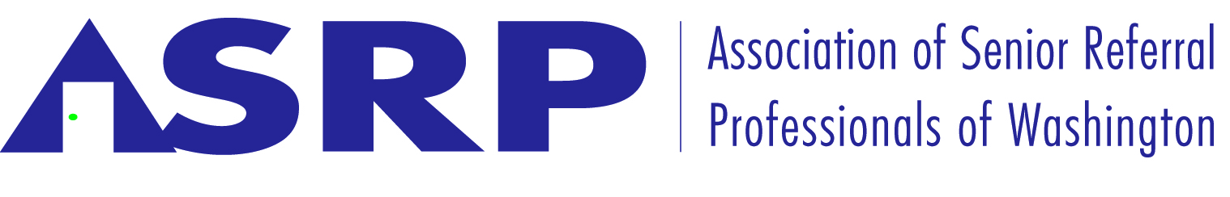

The Agents for a Fair Market place initiative –
Legislative Committee Report 11/23/16

Placement and Referral Agencies For a Fair Market Place
A collective formal complaint to the Federal Trade Commission, or any other government agency to assess the need for a further investigation into the business practices of some of the Online referral agencies.

The initiative is asking the Federal Trade Commission to evaluate their agreements with
the assisted living communities at large, (which some have called predatory) and assess if they violate any Federal or State Fair Business Practice laws as well as any Federal Antitrust laws.

Specifically, their current agreements which include a "First to send the referral owns the client for life" clause. Their agreements may obstruct fair competition.

Families/consumers should have the right to work with any agency that they choose at any time, regardless if they have filled out an online form.

Some of the online companies do in fact, put undue pressure on the assisted living communities and the residential homes if they do not pay them.

Families may be unknowingly and deceptively "entering into an agreement" with some online companies that contain a mandatory arbitration clause

Please Note:

We are not trying to put anyone out of business. The Online companies do service families to their approval and they have some very good and honest people working for them.

We are at issue with some of their business practices regarding their agreements with their provider partners.

At the end of the day, we are just asking for an "equal playing field"

I move that we encourage our members in signing the Agents For a Fair Market Place initiative by going to:
www.AgentsForAFairMarketplace.com

Chuck Bongiovanni, MSW, MBA, CSA, CFE
D: 480-719-4818 | Message 480-626-2450 | M: 480-703-7005
ChuckB@CarePatrol.com

