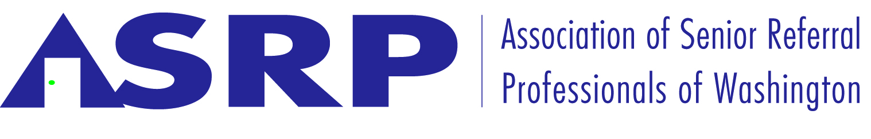
The Association of Senior Referral Professionals of Washington
Annual Report 2016

2016 Annual Report
Executive Board
President 2016
Lisa Doyle, CayCare, Inc.
President Elect 2016
Heidi Sheldon, Options For Seniors, LLC
Past President 2015
Abby Durr, Silverage, LLC
Treasurer 2016-2017
Abby Durr, Silverage, LLC
Secretary 2016
Open
Board of Directors:
Communications Chair
Evan Perrollaz, Cornerstone Healthcare Consulting, Inc.
Education Chair
Lisa Satin, The Right Place Senior Options, LLC
Ethics and Best Practices
Abby Durr, Silver Age, LLC
Legislative Chair
Heidi Sheldon, Options For Seniors, LLC
Membership Chair
Stan McKenzie, A Change is Afoot, LLC

Current Members
A1 Senior Care Advisors, LLC
A Chare Choice Agency
A Change is Afoot, Inc.
Adult Care Placements
Always Best Care
Assisted Living Options
All About Care
Care Patrol Seattle East Side
Care Patrol Greater West Seattle and South King County
CayCare, Inc.
Cornerstone Senior Care Solutions
Graham and Graham
Options For Seniors, LLC
Seattle Senior Care Consultants
Serving Our Seniors. LLC
Silver Age Senior Housing Referrals
The Right Place Senior Options

Affiliate Members
Legal Shield Services
Oregon Senor Referral Agency Association
Retirement Connection
Provider Reports

Mission Statement:

Association of Senior Referral Professionals of Washington is committed to establishing and promoting professional and ethical standards within the senior housing and care referral industry; as well as to those who provide supportive and ancillary services for older and other frail adults within the state of Washington.

A common business interest of all members is to create a unified and consistent voice which promotes, develops and facilitates:

- Ethical standards which create a quality experience for seniors, frail adults, and the people who support them.
- Recommended best practices and the education of members, with a shared goal of improving consumer awareness of options and increasing the ability of consumers to make informed decisions.
- Education to increase the knowledge and skills of members regarding aging, aging related products and services, communication, decision-making and conflict resolution.
- Education to increase consumer awareness of aging, senior housing and care options, effective processes for making life transition decisions, and to improve communication amongst family members, and with health care professionals and insurance carriers.
- A means for consumers, senior housing and care providers, health care professionals, other professionals or community members to provide feedback to the entire referral industry.
- The use of referral professionals as a means of making effective use of time, energy and resources for consumers and senior housing and care providers.
- Transparency, disclosure, accuracy of information, and effective, recommended business practices within the senior housing and care referral industry.
- Protection of consumers by communicating residents’ rights, current and future RCWs & WACs impacting consumers.
- Collaborative opportunities for consumers and members of the association to have a voice in future legislation and regulation regarding senior housing and care services.
- Protection of consumers by communicating the option to file complaints to the Ombudsman, The Department of Social & Health Services, Adult Protective Services, The Attorney General, and other regulatory or social service agencies.

Message from the President 2016
Lisa Doyle, CayCare, Inc.

2016 was the year of development. Developing what our associations regular events might look like, communication to the association at large and what our association means to the community. Our association began moving in the direction of being about the “cause” of educating on the law and more about being a community focusing on the common good of referral agencies.

We developed goals for the year as well. While I believe there is so much more to develop I believe this allowed our association to take a collective breath to move forward as a team.

Goals for 2016: “Clarifying our mission and communicating our distinctiveness.”
- Who are we and what do we want to accomplish in our industry?
- Increase Education and Communication to
  - Our association
  - Our referral sources
- Make an impact
  - Report what we are doing (once that is decided)
  - Encourage our association to share using social media
The monthly board meetings continued with even a few in person to remain connected. Decisions around communication to our membership as a main focus.

Special thanks to Abby Durr, for being there consistently throughout the year this year. Assisting me with communication development and mentoring me towards this role. Thank you to Evan Perrollaz for developing and sending out all special communications despite his very busy schedule. Thanks to all who served and took the time away from your own busy lives to accomplish what we did.

Committee Reports 2016
Communication
Evan Perrollaz, Cornerstone Healthcare Consulting, Inc.

Focus for 2016 has continued to center on further enhancing the website (www.asrpwa.org) for additional content and functionality, to make it easier-to-maintain member list, additional resources and speaker presentations. Additionally, we continued to look for ways to drive further awareness for the association across the industry. Communications also included a ASRP Face book page; be sure to like us today, that keeps members and prospective members up to date with the continuing events. If you have an industry feel good story please share on our page. We want to celebrate our industries successes.

Education
Lisa Satin, The Right Place-Senior Options LLC

Our goal is to increase the knowledge and skills of our industry through education, communication and networking. May 4th 2016 held open forum at The Meridian at Stone Creek in Fife. The three RN’s provided us with an open two way discussion Rauline Freier, Cordelia Dee Burris, and Lavinia Weisdepp. They offered insights on the assessment process and the operational challenges of working with state regulations and family expectations. They educated us about the expectations of nurses who do assessment for us to collect medical information as part of the intake process as routine practice. It was a lively worthwhile discussion. Evan Perrollaz, Cornerstone Senior Care Solutions, educated us on how to access the Association’s Facebook and how social media can help us connect better as an industry with good stories and heartwarming messages. Heidi Sheldon, Options For Seniors LLC, gave a legislative update that included Bill updates. See Legislative year in review for Bill details. Thank you, Heidi for commitment to helping keep us informed of the ongoing senior issues in Olympia.

On September 22nd 2016 we held an all-day conference at Aegis Rogers Park in Seattle the Speakers where Haleh Nekooard-Long, Psychiatrist at Cascade Behavioral Health, her talk was about the three “D’s” Dementia, Delirium and Depression. The need for more geriatrics mental health doctors and prevention strategies were discussed the goal to minimized in patient stays. The discussion was very insightful and educational. We also had Ruben Rivera-Jackman, King County Housing Authority; low income housing options in King County for 55+ including disabilities. We had a great discussion about LGBTQ concerns and practical ways to help everyone feel safe and welcome. These speakers were both especially great, our time with them went fast and ended too soon.

Although this was not officially an ASRP education event I wanted mention that one of our members Michelle Graham with Graham and Graham Eldercare Consultants, spoke at the Adult Family Home Council conference on October 21, 2016. Her topic was Referral Agencies: the pros, and cons, the legalities. Providers were educated 1. How to evaluate your marketing plan and the use (or not) of Referral Agents. 2. How to review a referral contract, the legal terms, and protection of AFH providers interest. 3. How the law protects consumers, including AFH providers. 4. The intent behind the requirements of the law. 5. The big “no-no’s” 6. How to avoid collection issues. 7. Ethical practices v/s unethical practices. Thank you, Michelle for educating providers about our industry.

Providing relevant education for our membership will continue to be a priority for ASRPWA. We look forward to your participation if you have an education idea please feel free to email me directly Lisa Satin at lisa@trpso.com .

Ethics/Best Practices
Mike Davis, Always Best Care - Eastside
In 2015, the Ethics and Best Practices committee created and the ASRP board approved a code of ethics for the organization. In 2016 we have enjoyed having this code of ethics in place. Since ASRP is still a relatively new organization trying to grow its membership we opted for a code of ethics that was more akin to guidelines rather than rules. We also adopted the Member Compliance Concern Policy as the enforcement process for violations of our code of ethics. Over the next few years we expect the code of ethics to be a slowly evolving document. 2017 may see a few new rules adopted and a few existing rules modified. It might be nice to see broader board and member buy-in for rules changes moving forward especially as some members have expressed interest in moving the code to a more rules oriented approach. We plan to review the Ethics and Best Practices at one our education session in 2017.
Legislative
Heidi Sheldon, Options For Seniors LLC

We actively advocated with legislators and WHCA membership on behalf of the Senior Referral industry during Senior Lobby Day in Olympia February 2016.

2016 The bills in Review

Skilled Nursing Facility Medicaid Reform (SHB 2678): Legislation reforming the skilled nursing facility Medicaid payment system passed the House on a 96-1 vote and the Senate on a vote of 46-0. Last year, SHB 1274 established the parameters for stakeholder work on reforming the skilled nursing facility payment system. A robust stakeholder process concluded with consensus recommendations on the majority of key issues, including establishing a fair market rental system for property, and adoption of quality measures for nursing home quality incentive payments. Changes to the system go into eﬀect in July 2016.

Long Term Care Pharmacy Standards (ESSB 6203): In early 2015, inspectors from the Pharmacy Quality Assurance Commission began to reverse long-standing positions related to the management of medications in skilled nursing and assisted living centers. Of most signiﬁcant note was a LTC pharmacy inspection ﬁnding that would have prevented nurses from transmitting chart orders to pharmacies on behalf of residents. Inspectors advised pharmacy principals that only physicians could transmit chart orders to pharmacies, despite being advised that this ruling would create signiﬁcant barriers to the timely delivery of medications to assisted living and nursing home residents. Most notably, the legislation provides clear direction to PQAC inspectors related to the signiﬁcant role of nurses in medications management practices. ESSB 6203 passed the Senate on a vote of 48-0, and the House on a vote of 97-0. The new standards go into eﬀect on July 1, 2016.

Assisted Living Medicaid Rates: Last year, the Legislature provided a 2.5 percent vendor rate increase for Medicaid contracted providers in assisted living, the ﬁrst increase in a decade. WHCA focused on DSHS practices that permit payment for services outside the daily Medicaid rate for adult family home clients, but not assisted living residents. Association of Senior Referral Professionals of Washington was successful in advocating for a budget proviso requiring a DSHS study related to the lack of equal payment; that proviso was included in the Senate budget (thank you, Senator Hill) and the ﬁnal consensus budget. The 2017 legislative session will be an opportunity to advocate for increased Medicaid rates.

CCRC Regulation (HB 2726): This year, legislation to regulate continuing care communities was introduced and successfully passed the Legislature. Initial legislation was so broadly written that it could have involved assisted living providers; The Association of Senior Referral Professionals of Washington advocated for the bill that passed the Legislature that was narrowed to solely include continuing care retirement communities. This new regulation includes everything from construction review, care levels and being able to provide nursing services in assisted living, to disclosure requirements and more. Feel free to look up HB 2726.

RCW 70.128.130 Adult Family Home Requirements Resident Evacuation issue in homes where the resident bedrooms/living areas are not at ground level. WAC 388-76-10820 says that each resident who requires assistance for evacuation needs a bedroom located on a ground level floor. Effective August 1st 2010 adult family homes applicants with residents bedrooms/living areas not at ground level will only be approved for care for independent residents. Having or adding a ramp from upper level to ground will no longer meet evacuation requirements for residents who need assistance. The Association of Senior Referral Professionals educated representatives on this issue and advocated for the evacuation in under five minutes as the standard and not if there is a ramp. Happy to report there has been a change in the ruling and the homes who have been waiting for construction review are being reconsidered.

It is with sadness that I report that my friend and Senator Andy Hill of the 45th district passed from lung cancer. He spoke often about how much he loved the people and communities he represented and how honored he was to serve them. I was honored to attend his memorial service on November 11th just a few days after the national election. I was struck by the love and non-partisan nature of his service, democrats, republicans, independents, people who were not political in any way all in attendance to honor a man who was always uplifted by serving others no matter their political beliefs. I will miss him greatly and so appreciate his support of me and our industry.

Legislative committee is monitoring for 2017 The Agents For A Fair Market Place imitative, the Do Not call list requirements of the Federal Trade Commission, and the outcome of the Assisted Living Medicaid Rates study to be completed by DSHS. The 2017 legislative session will be an opportunity to advocate for increased Medicaid rates.

Membership
Stan McKenzie, A Change is Afoot, LLC

This past year the Association welcomed five new members A1 Senior Care Advisors LLC, CarePatrol Greater West Seattle and South King County and All About Care. The new affiliate members are Retirement Connection and Provider Reports. We currently have total of 21 members, four are affiliate members. Our goal is to grow our membership through the use and exposer of our association brochure, Facebook page and web-site by our existing membership. By showing others about the value of being a member of ASRP we hope to grow our association to 30 members by end of 2017.

As membership chair I report that as of April 1st 2016 A Place For Mom is no longer a member of the Association of Senior Referral Professional of Washington. APFM was asked to leave due to business practices that did not meet the ASRP’s ethical standards. Mainly, full disclosure to consumer when obtaining new leads. APFM business practices were legal according to their view of RCW 18.330, the Elder referral law in Washington State, yet did not meet our associations standards and they were not willing to change even after ASRP formally asked them to adjust.

Participation in the membership committee is always welcome. Every member is encouraged to join the efforts of the membership committee.

Financials for the year
Abby Durr, Silverage, LLC

In 2016, ASRP generated funds through membership dues. Membership dues are $200 per year for a referral company. Affiliate membership dues are $100 per year. Affiliate members offer supportive services and products to the senior housing and care industry and are non-voting members of ASRP.
Our fiscal year is January 1 - December 31. Our bank balance on Jan. 1, 2016 was $1,804.42. Membership dues in 2016 generated $2,800. Notable operating expenses are as follows:
- Website Maintenance: $250.88
- Marketing & Advertising: $314.97
- WHCA Membership: $500.00
- Misc. $194.87
- Insurance: $1,093.00 (to be paid by December 2016 for 2017 coverage)

Current bank balance is $1,132.04 and is the only asset of the Association of Senior Referral Professionals of Washington.

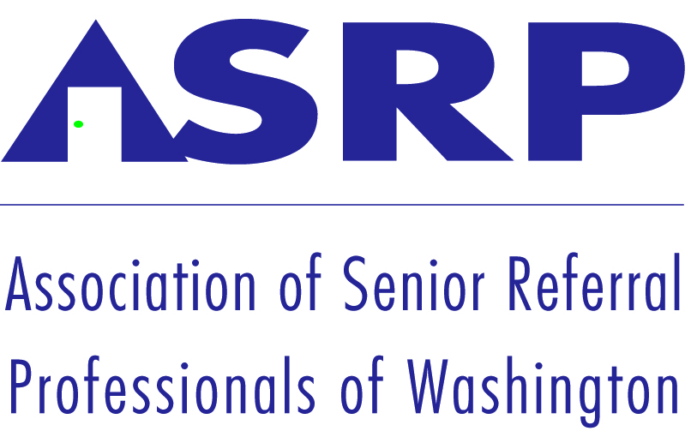

9224 Slater Ave NE Suite 215
Kirkland, WA 98033
www.ASRPWA.org

